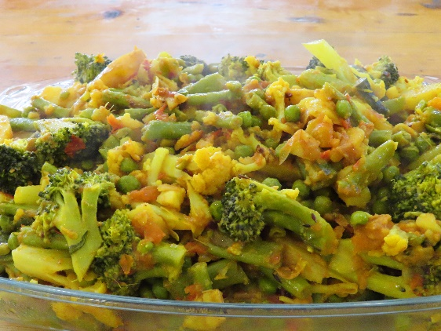
Takari- Nepalese Vegetable Curry

Ingredients:
4 cups mixed vegetables ie pumpkin, eggplant, broccoli, mushrooms
2 tblsp oil
2 onions finely chopped
1tblsp Ginger
1 tblsp garlic
1 tsp cumin
1 tsp turmeric
4 chopped tomatoes
1 tsp red chilli flakes

- Chop all vegetables into small cubes and set aside
- Heat oil in a pan over medium heat, add chopped onions and cook until lightly brown
- Add potatoes and cook for 5 minutes
- Add other vegetables except tomato and cook for 5 minutes
- Add ginger, garlic, tomato, cumin, turmeric, chilli
- Stir and cover the pan with a lid, cook for 10 minutes, stirring occasionally
- Add ½ cup of water partway through cooking if needed

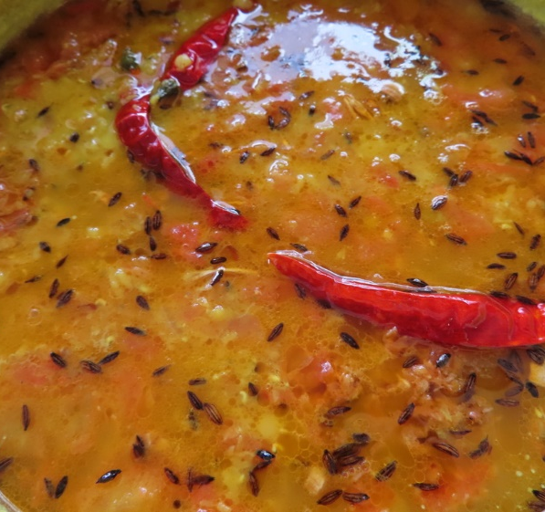
Lentil Dal

½ litre water
1 cup lentils
½ tsp turmeric
½ tsp salt
2 tsp sunflower oil
½ tsp cumin dried
Oil fry toppings
1 tsp cumin seeds
2 tsp dried chillies
1 tbsp garlic paste
2 tbsp sunflower oil

- Add water, lentils, cumin powder, turmeric, oil and salt to a saucepan
- Cook on medium heat for 30 minutes stirring regularly
- Add water if the mixture starts to get dry

Oil fry topping
- Heat oil and cumin seeds until the seeds turn brown
- Take the oil off the heat and add chillies and garlic
- Fry until the mix goes brown

Add the oil mixture to the top of the dal for serving

Alu Dum- Fried Potatoes
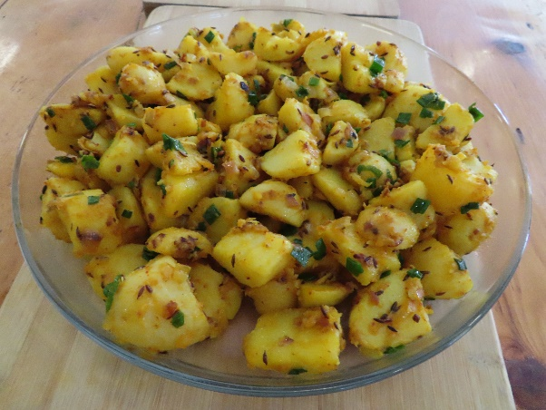
500g potato
½ cup Green peas
1 diced onion
2 tsp cumin seeds
1 tsp turmeric
1 tsp chilli flakes
1 tsp ginger
2 tsp garlic
2 tblsp oil
Spring onion chopped

- Heat oil in a pan over a medium heat, add cumin seeds
- When they turn golden, add onion and fry until brown
- Add potatoes and turmeric, mix in peas, cover and cook for 5 minutes
- Add in remaining ingredients and cook for 5 minutes until potato is tender

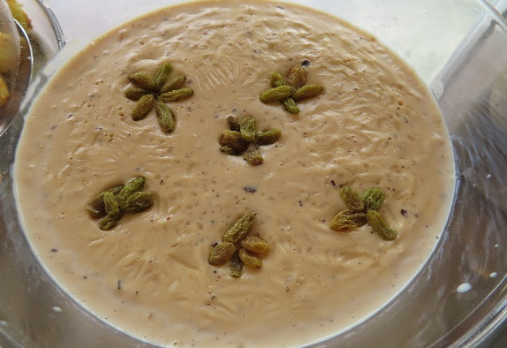

Kiri (rice pudding)

Ingredients:
- Milk (2 litres)
- Rice (1 cup of round rice)
- Cashews or coconut chopped (2 table spoons)
- Butter 2 table spoons
- Sugar (2 tablespoons or according to your taste)
- 5 Cloves crushed
- 5 Cardamom pods

Method:

- Wash the rice and keep aside. Chop nuts and crush cloves and cardamom using a mortar and pestle.
- Heat the milk in a heavy bottomed pan.
- When the milk starts boiling, add the rice, nuts, crushed spices and sugar. Boil for 10-15 mins.
- When the milk reduces to 3/4, reduce flame to low, stir the rice occasionally so it does stick to the pan. Cook for 25-30 mins till the rice is cooked and the milk is reduced to half. As the milk reduces the dish will become thick in texture.

Place in a serving dish and garnish with chopped nuts and raisins. You can serve it hot or cold.

